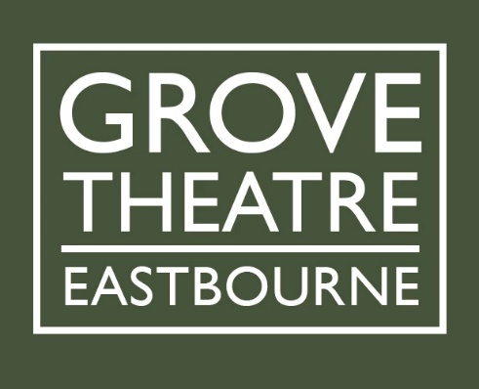
Grove Theatre, Eastbourne
Proposal for an Incoming Event

Introduction
Thank you for your enquiry about bringing your event to the Grove Theatre Eastbourne. Please read this document thoroughly before completing the relevant sections.

Please be aware that although we are keen to meet your first-choice dates, we may be booked for them already as demand for use of our spaces is high. We also reserve the right to refuse hire if we do not feel the proposal meets our policies or principles.

We ask that all hirers subscribe to our Safeguarding and Health and Safety policies. We have strong diversity and equality principles. We recognise the strength that diversity brings to our work. We aim to reflect the diversity of the communities we support.

Submission Process
1. Please read this document fully.
2. Complete the relevant sections.
3. Email the form along with the script and any supporting documents to: thegroveeastbourne@gmail.com
4. Receive an initial email to acknowledge receipt within 3 working days
5. Receive a full reply within 7 working days

Terms of Hire
60/40 Box Office split in your favour. This incorporates a pre-event hire period for preparation - to be agreed - on the day of the performance (or the first performance if more than one). Any hours requested over and above this time will be charged at our standard rate of £25 per hour.
Standard ticket pricing at the Grove is set as follows:
Full Price £12 Party of 4 £43
Concession* £10 Friends / Previews £8
*60 or older, unwaged or student

If you have any queries, please contact us at: thegroveeastbourne@gmail.com

Contact Details
Name of Organisation: | Company No. / Registered Charity No. (where applicable):
Contact Name: | Address:
Contact Telephone No: | Mobile No:
Email address: | Website address:
Insurance Certificate Numbers:

Section I – Your Organisation

All performing arts companies will be expected to have Public Liability and Employer’s Liability Insurance in place should the proposal go to contract.

Section II – Your Event

Event Details
Title of Event
Description of Event (please provide as much information as possible, e.g. performers involved, production concept if theatre event)
Potential Date / Date Range(s) |  | Times required
Type of event |  | Number of Performers
Duration of Event |  | Tech Requirements (if known)
Access Requirements

Interval? YES / NO
Flexible with potential dates? YES / NO
Are you subject to the provisions of a collective agreement with a trade union or professional association (eg Equity, Musicians Union)? YES / NO
If YES please state: __________________
Educational Offering (e.g. workshop)? YES / NO
If YES please state: __________________
Access Offering (e.g. signed performance)? YES / NO
If YES please state: __________________
Does your event include Under 18s? YES / NO
Financial Information
Please tick one of the following –
Funding is in place
We’re in the process of obtaining funding
Funding is not in place
We are self-funded

Sign/type name to indicate you have read the above:

Role:

Date:

